Dear Student,

Early in the morning on every class day, I want to send you a summary of the topics to be discussed later in the class (two-minute read) to onboard you to the subject. Please spend a couple of minutes, mull over it, if possible, discuss it with a friend or sibling on the breakfast table so that it gets riveted in your mind. This is the first such summary.

Entrepreneurial ventures are those that are built around a vision, driven by innovations, intrinsically a scalable model, and offer a superior value proposition. Entrepreneurs identify opportunities in adversities, create an innovative and competitive solution to alleviate the adversities and make the solution available to the target segment through a superior value proposition to increasingly satisfied repeat customers. In today’s fast-changing corporate world, any business has to follow the tenet s of an entrepreneurial model to sustain and grow. The entrepreneurship course aims to educate learners on how to start, or translate an existing business into, an entrepreneurial venture. Therefore, the subject is relevant to any future executive irrespective of whether s/he aspires to be an entrepreneur or not.

Creating something gives an enormous sense of fulfilment. Try planting a sapling and watch it grow. You will feel as if you are the creator of it. Create a new venture, and you will indirectly create so many streams of values to a large number of stakeholders that you will receive indescribable joy and happiness. Of course, there are ups and downs, success and failure.

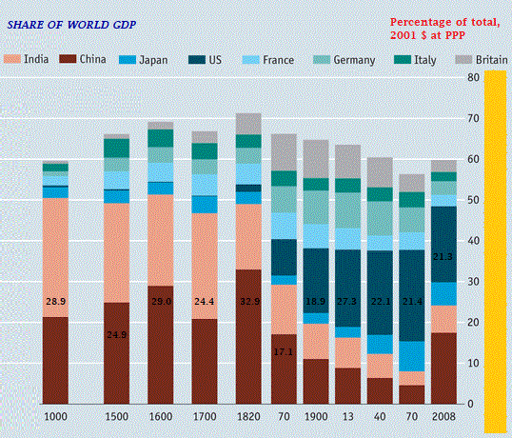Let us have a bit of historical, present, and future perspective on entrepreneurship and the economic development of this civilization. Since antiquity (say 500 BC) until the invasion by the British East India company of our country (1757), India had been one of the wealthiest nations (and THE richest for many centuries) in the world. India’s GDP was more than 30% of the total world GDP. Everything changed with repeated invasion culminating to the British rule and our contribution to global GDP came down to 3.8% in 1952 (India was the POOREST COUNTRY IN THE WORLD1), which further went down to less than 2% during the later part of the twentieth century. If you are intrigued by our richness and poverty, know for a fact that Indians had always been innovative and entrepreneurial. Britain and France could never compete with artisans in India, and their markets were dominated by Indian businessmen. The British destroyed everything that made us what we were. Then they invented the first cotton jenny (1764–1775) for automatic spinning to compete with the Indian textile artisans, and the steam engine [James Watt (1763–1775) improved Newcomen’s engine]. These developments engendered sweeping industrialization, revolutionizing the business in entire Europe. New technologies brought about the birth of innumerable entrepreneurs, giving them an unsurmountable competitive advantages while the Indians remained under seize. We lost on all counts. Today, thanks to the growth in entrepreneurship, our contribution to the global economy in 2017 was 7.4% (on purchasing power parity basis) and we are on course to repeat the history.

Figure 1: Contributions of major economies to global economy2

Source:  https://en.wikipedia.org/wiki/Timeline_of_the_economy_of_the_Indian_subcontinent.

The takeaways from this discussion are that entrepreneurs are the main drivers of the economy. They provide

-          Jobs.

-          Increase government income that propels all developments, healthcare, and other infrastructure (look around you, and all that you see are the results of the hard work of entrepreneurs).

-          Bring new technologies.

-          Promote export and, thus, increase the value of our currency.

-          Promote education

-          Improve healthcare system

-          You name it. Every aspect of the quality of life of citizens are impacted by the intensity of entrepreneurship in a nation.

The simplest way to live a life of pride is to be an entrepreneur, create wealth for self, extended family members, and the country, and make the country stronger. If China has emerged as a global super power, it is entirely because of their entrepreneurs. A government can do only so much.

On the flip side, about 1% of great ideas are translated into a commercially successful enterprise, primarily because generating creative ideas and building cutting edge products are tiny components of entrepreneurial success. There is a lot to learn about entrepreneurship. Business strategies may look obvious and intuitive, but unless one takes a plunge and learn it explicitly, they repeat the same costly mistakes that others have been committing over and over again for decades.

Notably, the new breed of entrepreneurs has been continuously challenging the status quo and disrupting incumbent businesses. Corporations, therefore, look for entrepreneurial talents in potential employees. Such skills consist of the capability to identify opportunities in adversities, the ability to estimate the potential risk, adopt appropriate strategies to alleviate the risk and create a superior value proposition and translate the idea into a robust and sustainable business model.  People with such qualities can take a leadership role and drive success. So, they are most sought after in today’s corporate world.

A new kind of corporate strategies is in play in recent times, known as **corporate entrepreneurship**. Let us understand with an example. Google offers 20% of the official time of all its employees to engage in any innovative initiative of their own, using company space and all other necessary resources, including money. The employees are expected to define a problem and independently come up with a tenable, feasible, and commercially relevant solution and take it to market through an entrepreneurial venture. Google will have the first right to refuse to buy the technology (meaning that if you want to sell it, you do it at a price higher than what Google is ready to pay). In this process, not only do you get to churn and challenge your intellectual capability, but you also reap the benefit of your creative and unique cognitive talents. Your entrepreneurial knowledge will be necessary to emerge victorious in such endeavours. Many companies have been promoting corporate entrepreneurship of different models, mainly to promote innovation and to retain top talents.

Our idea of a regular job will be challenged in the years to come because of the advent of new technologies in automation and the demand by customers for new experiences. The application of continuously emerging technologies such as drones, AI, robots, and IoT will disrupt the job market in unexpected ways. Only those will command jobs that are innovative and entrepreneurial.

In summary, whether you want to become an entrepreneur today or a few years later, or want a dream job, or you want to perform exceedingly well in any position, your knowledge in entrepreneurship will never be redundant.

References:

1.       “Of Oxford, economics, empire, and freedom.” The Hindu. Chennai. 2 October 2005. Retrieved 10.03.2020 — Manmohan Singh

2.       <https://en.wikipedia.org/wiki/Timeline_of_the_economy_of_the_Indian_subcontinent>. Retrieved 10.03.2020

You guys are highly talented and gifted. I look forward to a mutually learning experience.

Best,

Manoj K Mondal